Capstone Planning Document: -

Initially, for this project I had considered making a simple basketball game for VR but considering the challenges and feasibility of this aspect I had decided to go for creating the experience of outer space in VR and hence the idea for the game VR space rider was born.

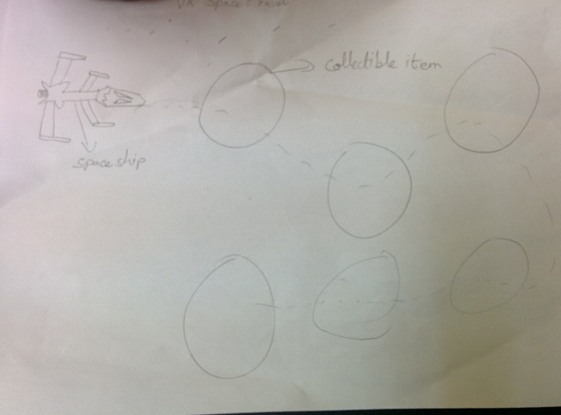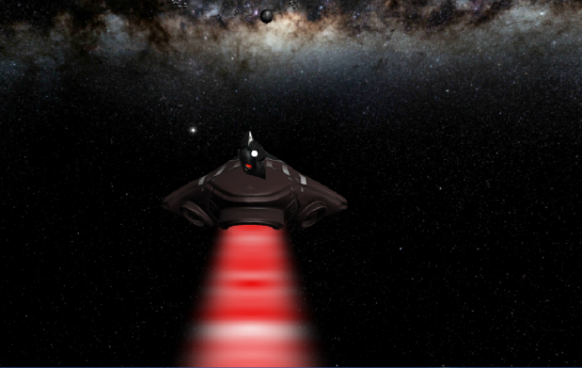

In the photograph above, this was the initial idea I had for the game wherein, the user would be controlling a spaceship and collect coins that are present one after the other. After that I realised that this is not that much effective as felt like just another third person game. Hence, this idea was cancelled and I had decided to make VR Space rider POV and the intention of this game was the same that is, to provide an experience of outer space to the user.

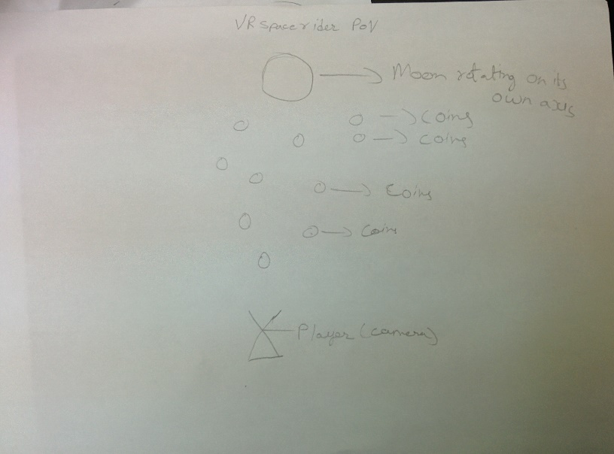

The Above photograph is the closest replica on the game in 2D space. This photograph is more like an eagle eye view of the game scene where the user is denoted by a triangle and the coins are marked with small circles and the bigger circle is of the moon.

In conclusion, the elements in the game I had used were taken from the Unity Asset store created by Adam Bielcki and Robbin Harris. Adam Bielcki was the one who had created the Milkyway skybox and Robin Harris was the one who had created the Skull coins used the in the game.

The photographs of these can be seen below.

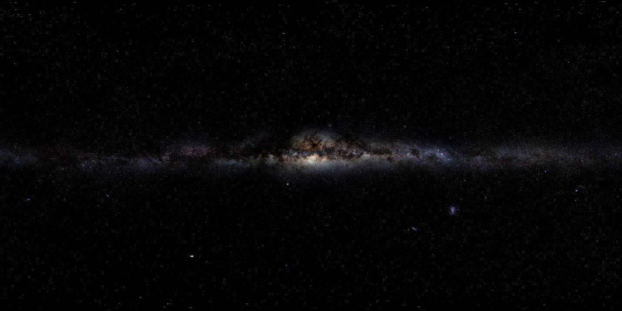 Milky way galaxy

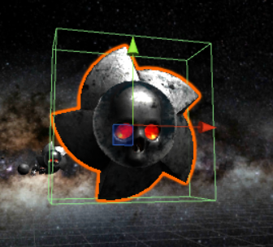

Skull Coins